**IBRI COLLEGE OF TECHNOLOGY**



Department of Information Technology

**Tracking System using GPS and GSM Module.**

_______________________

A Course Project (ITSE414) Presented to

The Faculty of Information Technology Department

Ibri College of Technology

_______________________

Aalya Abbas Alquami (76S1515)

Asia Rashid Said Al-saidi (76S159)

Sheikha Khalifa Al-Quyudhi (76S1512)

**APPROVAL SHEET**

This course project entitled "Tracking System using GPS and GSG ", in partial fulfillment of the requirements for bachelor level ,prepared and submitted by Sheikha khalifa al-qaiyadi (76S1512), Aalya Abbas Alkuimi (76S1515),Asia Rashid al-saidi (76S159,has been examined and recommended for acceptance and approval for final oral examination presentation.

**MR. SARAVANAN**

Supervisor

**APPROVED** by the panel on Oral Examination with a grade of __________.

**Dr Mr.**

Assessor Assessor

**Mr. Ahamed Nishath**

Coordinator

**ACCEPTED** as a partial fulfillment of the requirements for Bachelor Level, Semester 1, AY 2019-2020.

Approved by:

**Dr.Duhai Khalifa Duhai Al Shukaili. Mr. William M.Ancheta**

HoD– IT Department HoS – IT Department

**DEDICATION**

The satisfaction that accompanies that the successful completion of any task would be incomplete without the mention of people whose ceaseless cooperation made it possible, whose constant guidance and encouragement crown all efforts with success. So let me mention for people who played a very good role in each and every aspect to make sure that this project is done completely and according to the user requirement.

First of all I would like to thank my Head of the Department **Dr.Duhai Khalifa Duhai Al Shukaili** and Head of the Section **Mr.William M.Ancheta** to give me the opportunity to do this project. Secondly I would like to thank my supervisor **Mr. Ahamed Nishath** He plays his role very well as he shows the guidelines and giving some new idea or suggestion to improve my project and complete the project successfully. Also I extend my thanks to all my Lectures and my friends who have supported and encouraged me to complete my project successfully.

**TABLE OF CONTENTS**

|  |  |
| --- | --- |
|  | Page |
| Title page…………………………………………………………….. | 1 |
| Approval sheet……………………………………………………….. | 2 |
| Acknowledgment……………………………………………………. | 3 |
| Table of Contents …………………………………………………….. | 4 |
| **CHAPTER 1 –INTRODUCTION**  Abstract………………………………………………………………. | 6 |
| Problem Statement………………………………………… |  |
| Objectives of the Project………………………………….. |  |
| Scope of the project………………………………………………. | 7 |
| Significance of the project …………………………………. |  |
| **CHAPAPTER 2 – REQUIREMENTS AND ANALYSIS………………**  **Literature Review** | 8 |
| System Requirements Analysis: |
| HW requirements and SW requirements………………….. |
| Functional Requirements……………………………….. |
| Non-functional Requirements……………. | 10 |
| **CHAPTER 3 –SYSTEM DESIGN**  Logic Design--------------------------------------------------  System Architecture ----------------------------------------  Physical Design (user-interface)----------------------  Usecase diagram ----------------------------------  Activity diagram ---------------------------------- | 11  12  16  17 |
| Important Component------------------------------------------------ | 18 |

**6 References -------------------------------------------------------------** 21

**ABSTRACT**

Tracking system using GPS and GSM module. Nowadays people frequency travelling and the chances of losing their things are increasing. Suppose you keep your laptop in a public place and you leave it unattended for sometimes, then you could not find it there this is one of the problem that you will face in the colleges and universities nowadays. This project focus on solving this problem in easy way. We are proposing to design system to track our laptop using Arduino and GPS technology. This will help people to track their lost items like laptop and many others. We are going to connect GPS model in our laptop, this GPS will sense the current location of our laptop, when we could not found our laptop in the place that we leave it in it, then we will send massage to our laptop and after some time the GPS will reply us with current location of our laptop where it is now and then we can find the location on Google Map and then we can track it as soon as possible. This will save our time while searching in wrong places.

**CHAPTER-1 –INTRODUCTION**

This chapter contain detailed information about the existing problem we want to solve it in this project, objectives, scope and significance.

* 1. **Problem Statement**

The Tracking System using GPS and GSM technology project is designed and develop to accommodate the needs of today. In this project we are going to make a system for tracking valuable things in Oman, It will help people to track their things easily. So you may not need to ask anyone for help and you will solve the problem as soon as possible by yourself. The desired output from the system will be the data such as position and time obtained from the GPS receiver and will displayed on the phone screen. The tracking system is an enhanced system that allows a user to track the things using GPS along with GSM module.

**1.2 Objective**

The objective of this project is to design and develop Tracking System using GPS and GSM Technology. In order to fully understand both GPS and GSM technology, the research and study on how both technology works is essential to complete the whole project.

The objectives of this project are:

I. To study and investigate the basic operation of the GPS module.

II. To design and develop the GPS/GSM tracking system.

III. To help people to find their items easily.

* 1. **Scope**

Tracking system using GPS and GSM module which helps people to track things when they lose it or maybe stolen by others. this project is a security tool for people to track their things easily where Students in colleges and universities, also Academic and non-academic staff can use this system, this project is useful because It will help the people to track their things in two cases first if forgetting things in public place/lost it, second if Stolen or taken by others.

**1.3Significant**

Nowadays, the world is no longer the same as in the past. It became difficult to leave your personal things in public, because of the lack of security necessary for protection. But sometimes you have to do that. For example, it’s hard for you to carry your laptop wherever you go. So we made a project that works to track your important things by fix advice in your laptop, for example or anything else important to you. The importance of our project is to identify and track the direction of your laptop, for example. Our project will work to determine whether your laptop is stolen or that you have forgotten where you put it. This saves your time and properties. Also, it works to catch thieves quick.

**CHAPAPTER-2 – REQUIREMENTS AND ANALYSIS**

**1.DATA GATHERING**

**1.1Literature Review**

This related studies contain information about tracking system using GPS and GSM module, and how this system is going to be built in future.

* 1. **Humaid Alshamsi, Veton Këpuska, Hazza Alshamsi (2016),** This paper explains the design and implementation of real-time GPS tracking system Using Arduino. When a user makes a call to the number recorded on the GPS-GSM shield attached to Arduino, the user Receives location coordinates with data that is continuously stored on an SD card simultaneously. And that's a big deal. Application for vehicle security, vendor tracking and special drivers.
  2. **NANDINI SHARMA** ,This is paper is from project of NANDINI SHARMA, it took about her project which has some information related to our topic, it took about military, navigation, automobile, artefacts, fleet management, remote, monitoring, remote control, and security system. Also it took about GPS and GSM.
  3. **Venkata Surya Narayana T* and S. Anil Srikanth(2013),**this paper took about the need of Organizations facing the real problem on physical, mechanism to protect their IT systems such as Laptops or notebooks and palmtops. All IT systems, have become difficult to protect because they can easily be stolen.they design an anti-theft security system to track the location of your laptop. Using the GSM / GPS module connected to your laptop.
  4. **Mardiana bint Mohamad Noor,Wan Haslina Hassan(2018)**, This paper explains the main objective of IOT security also provide an overview of the current state of the IOT security research ,the relevant tools,IOT modellers and simulators.in this paper they are discussing about the IOT architecture which is based on a 3 –tier/layer system which consists of a perception/hardware ,a network /communication layer and a layer of interface/service.in this research also they are focusing more in security mechanisms of IOT development and the mine objective of applying this mechanisms is to pre-serve privacy ,confidentiality, ensuring the security of the users.

**2. Requirements**

* 1. **Software Requirement**
* Web Server.
* Data Base (SQL).
* Arduino Program.

**2.3 Hardware Requirement**

* Arduino
* GSM Module
* GPS Module
* 16x2 LCD
* Power Supply
* Connecting Wires
* Laptop.
* SIM card.

**2.4 Functional Requirements**

|  |  |  |
| --- | --- | --- |
|  | **2.4.1 User Requirement** | **2.4.2 System Requirement** |
| 1 | User should register in the system | Check if the user is registered or not. |
| 2 | Send message to get the value of the location | If user is already registered, he will receive a message with value of longitude and latitude. |
| 3 | Take the value and check the location on google map. | The system will identify the location. |

**2.5 Non Functional Requirements**

The following non-functional requirements are applicable and suitable for our project:

❖ Usability: The Tracking system is user friendly and easy to use.

❖ Security: It protect our laptop/items from being sold in any hardware markets.

❖ Maintainability: The Tracking system is able to make changes in future according to the customer requirements.

❖ Performance: The Tracking system is able to perform all the operations in required time.

❖ Portability: System can be used in any laptop/items.

**2.6 REQUIREMENT SPECIFICATION**

Registration is one of the important requirement in this project.to use this system you have first to register your number to get access into the system, more further to send and receive message through the GSM module to get location values. the constraint of this system is the user has to enter the correct number with at least eight numbers.

**CHAPTER-3 –SYSTEM DESIGN**

This chapter contains the logical design (Program Flowchart diagram) and the physical design (User Interface diagram) of the tracking system using GPS and GSM module.

**3.1 Logic Design**

This flow-chart show that the GSM first wait for a request from the user for example ask for the location to do tracking. if he has not registered before, then he can’t receive any location details, he has to do registration before that. If he is already registered, then GPS coordinate values to the GSM, GSM gets data and store it on SD card then send it the authorized user.

valid

GSM waits the request

(location /shut down/change number /register new number)

(l

NO

YES

GPS ON (send request)

(coordinate values)

GSM gets data and send

Store on SD card

End user

Figure 3.1: logic design

**3.2 System Architecture**

**system architecture** or **systems architecture** is the [conceptual model](https://en.wikipedia.org/wiki/Conceptual_model) that defines the [structure](https://en.wikipedia.org/wiki/Structure), [behavior](https://en.wikipedia.org/wiki/Behavior), and more [views](https://en.wikipedia.org/wiki/View_model) of a [system](https://en.wikipedia.org/wiki/System).An architecture description is a formal description and representation of a system, organized in a way that supports reasoning about the [structures](https://en.wikipedia.org/wiki/Structure) and [behaviors](https://en.wikipedia.org/wiki/Behavior) of the system.

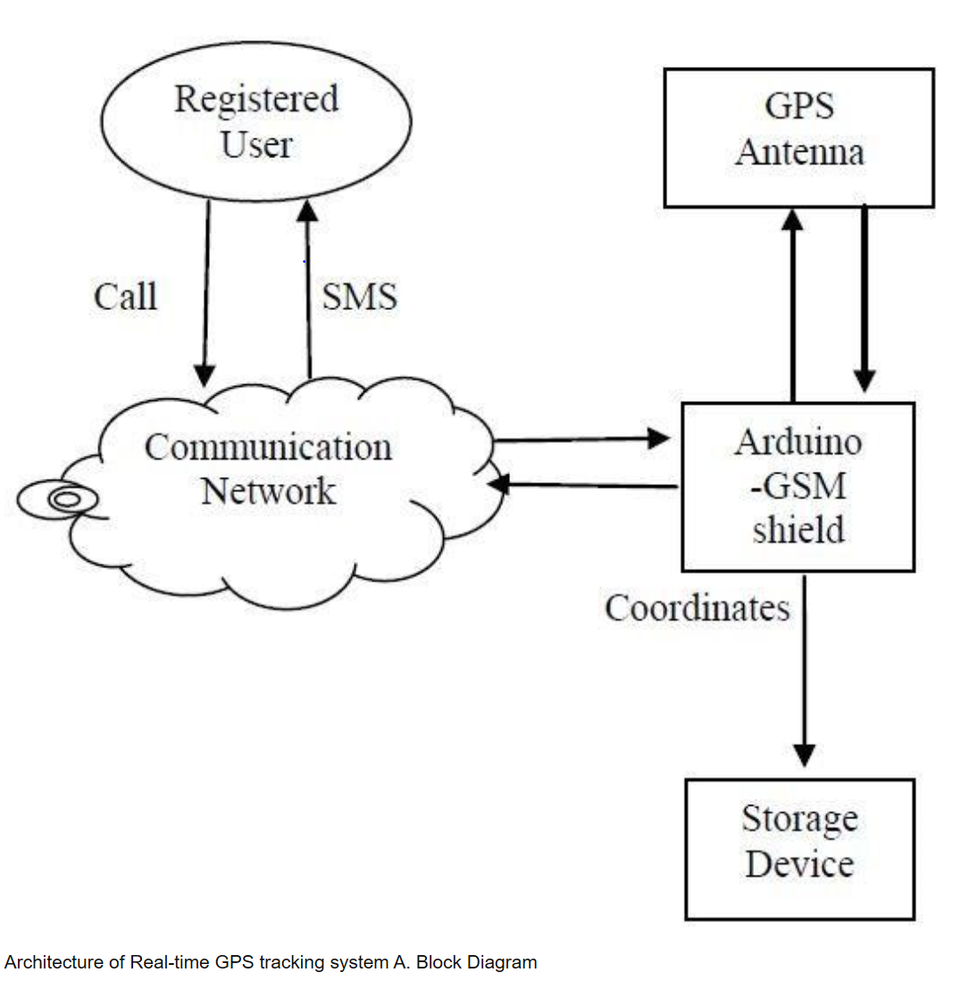A system architecture can consist of system [components](https://en.wikipedia.org/wiki/System) and the sub-systems developed, that will work together to implement the overall system. There have been efforts to formalize languages to describe system architecture, collectively these are called [architecture description languages](https://en.wikipedia.org/wiki/Architecture_description_languages).

**3.2 Physical Design (user-interface)**

This diagram shows the process the user will do to register his number to get the location values, if has not registered before he can get details about the location of missing item, the user can register many numbers in GSM to use the system from different mobiles.

Register number in the GSM

Send SMS to get location values

Get location values in SMS

Figure 3.2.1: user-interface

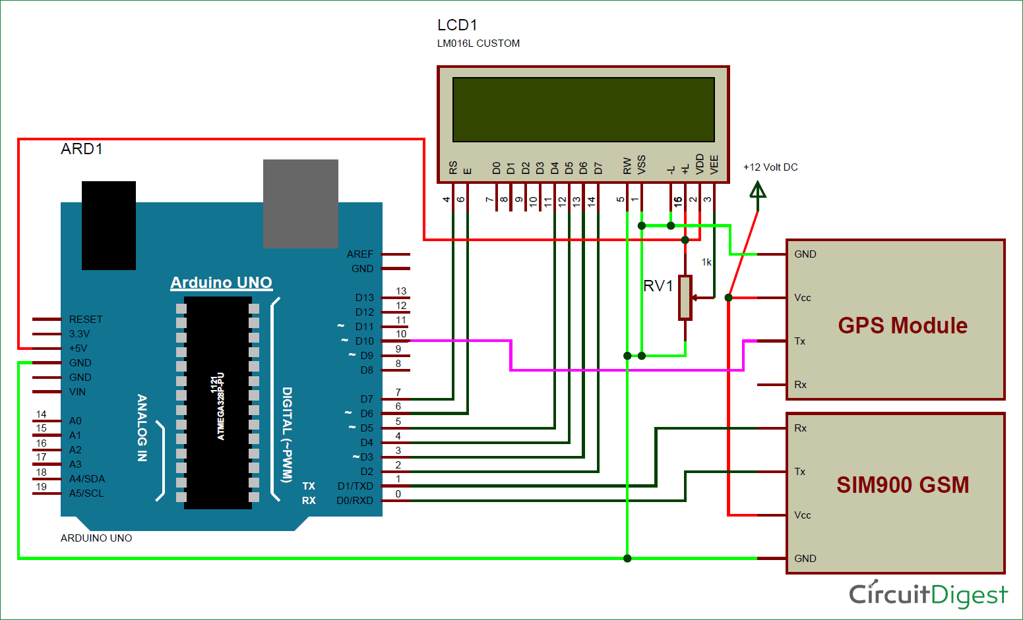

Figure 3.3.2: physical design

In this project, Arduino is used for controlling whole the process with a **GPS Receiver and GSM module**. GPS Receiver is used for detecting coordinates of the laptop. GSM module is used for sending the coordinates to user by SMS. And an optional 16x2 LCD is also used for displaying status messages or coordinates. We have used GPS Module SKG13BL and GSM Module SIM900A.

When we ready with our hardware after programming, we can install it in our laptop and power it up. Then we just need to send a SMS, “Track Vehicle”, to the system that is placed in our laptop

Sent message is received by GSM module which is connected to the system and sends message data to Arduino. Arduino reads it and extract main message from the whole message. And then compare it with predefined message in Arduino. If any match occurs, then Arduino reads coordinates by extracting $GPGGA String from GPS module data (GPS working explained above) and send it to user by using GSM module. This message contains the coordinates of laptop location.

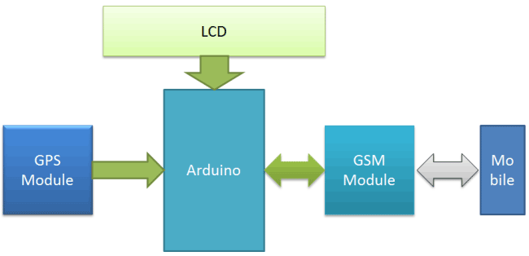

Figure 3.2.3: working system

**3.3 Usecase diagram**

In this Usecase diagram the user have to register in the system before using it to track the lost item. Then the user can send a message with “tracking system” as a content of the message to the system, after this process the Arduino will recognize the content of the message, then it will send the coordinates values by GPS to the user in a text message. After the user receive the message he will take the coordinate values and put them in google map to see the location of his/her lost thing. Then he can view the whole map of that location.



Figure 3.3: Usecase diagram.

**3.4 Activity diagram**

This diagram shows the activity diagram of the registration function, where the user will register their number in the system, the he can use this system to send and receive messages to get the location from the GPS and then the users can find the location on google map to find the lost thing.



Figure 3.4: activity diagram

**5.Important Components**

**These are the important component in this project to build the tracking system using GPS and GSM module.**

* 1. **GPS tracking unit architecture**

The Global Positioning System (GPS) is a satellite navigation system that provides us with information about time, location and all weather conditions anywhere on or near the Earth. It contains a GPS module to receive the GPS signal and calculate the coordinates with a large memory to store the coordinates, additionally contains the GSM/GPRS modem to transmit this information to a central computer either via SMS or via GPRS in form of IP packets. The system provides important capabilities for military, civilian and commercial users around the world. The U.S. government has created this system and it maintains it and has made access to it free of charge to anyone who has a GPS receiver and wants to use it.

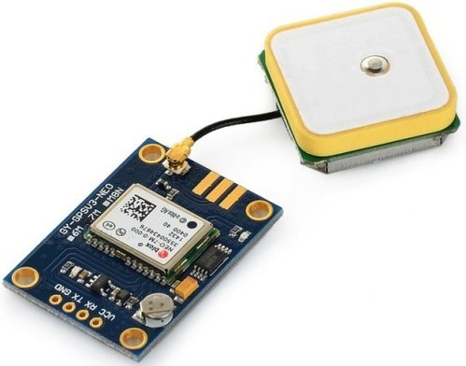

Figure 5.1: GPS unit.

**5.2 Arduino**

[Arduino](http://arduino.cc/) is an open-source platform used for building electronics projects. Arduino consists of [Arduino](http://arduino.cc/) is an open-source platform used for building electronics projects. Arduino consists of both a physical programmable circuit board (often referred to as a [microcontroller](http://en.wikipedia.org/wiki/Microcontroller)) and a piece of [software](http://arduino.cc/en/Main/Software), or IDE (Integrated Development Environment) that runs on your computer, used to write and upload computer code to the physical board.

The Arduino platform has become quite popular in the individuals simply starting out with physical science, and permanently reason. not like most previous programmable circuit boards, the Arduino doesn't want a separate piece of hardware (called a programmer) so as to load new code onto the board you'll be able to merely use a USB cable. In addition, the Arduino IDE uses a simplified version of C++, making it easier to learn to program. Finally, Arduino provides a standard form factor that breaks out the functions of the microcontroller into a lot of accessible package.

The Arduino hardware and package was designed for artists, designers, hobbyists, hackers, newbies, and anyone curious about making interactive objects or environments. Arduino will interact with buttons, LEDs, motors, speakers, GPS units, cameras, the internet, and even your smart-phone or TV! This flexibility combined with the actual fact that the Arduino package is free, the hardware boards are pretty low-cost, and both the package and hardware are simple to learn has LED to an outsized community of users who have contributed code and discharged directions for a huge kind of Arduino-based comes.

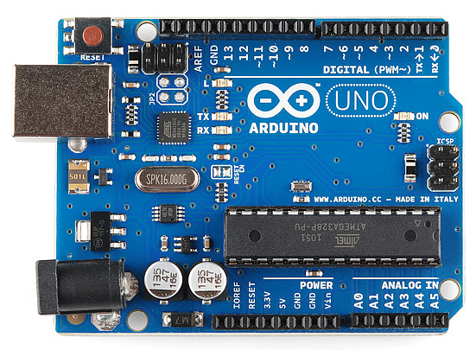

Figure 5.2: Arduino.

**5.3 16x2 LCD**

LCD (liquid crystal Display)

Screen is an electronic display module. LCD is very basic module and commonly used in many device. This LCD it can display 16 character per line and there is two lines. This LCD contain commend and data. The commend register stores the commend instruction give to the LCD. The data register stores the data to be displayed on the LCD.

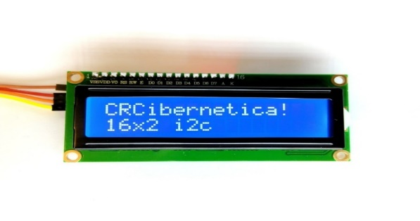

Figure 5.3: LCD unit.

* 1. **Power Supply:**

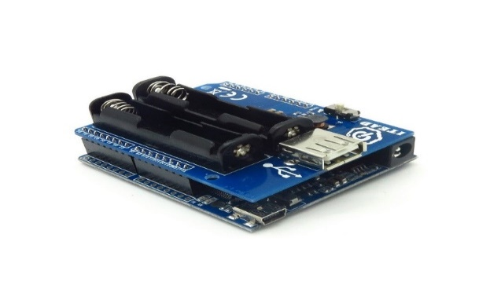

The board can be **supplied** with **power** either from the DC **power** jack (7 - 12V), the USB connector (5V), or the VIN pin of the board

Figure 5.4: Power Supply:

.

**References**

1. **Humaid Alshamsi, Veton Këpuska, Hazza Alshamsi (2016),** "Real Time Vehicle Tracking Using Arduino Mega", [Florida Institute of Technology](https://www.researchgate.net/institution/Florida_Institute_of_Technology),December 2016 *with* 10,728 Reads. <https://www.researchgate.net/publication/319345188_Real_Time_Vehicle_Tracking_Using_Arduino_Mega>.
2. **NANDINI SHARMA**,"VEHICLE TRACKING SYSTEM USING GPS-GSM",THE INSTITUTION OF ENGINEERS (INDIA) KOLKATA,ST-579083-8, AMIE SEC B (E&C),https://www.academia.edu/35534098/PROJECT_REPORT_VEHICLE_TRACKING_SYSTEM_USING_gps-_gsm_THE_INSTITUTION_OF_ENGINEERS_INDIA.
3. **Venkata Surya Narayana T* and S. Anil Srikanth(2013**),"Laptop tracking mechanism using GSM/GPS technology"**,** Elixir Comp. Sci. & Engg. 60 (2013)1621416218. https://www.researchgate.net/publication/264859227_Laptop_tracking_mechanism_using_GSMGPS_technology.
4. **Mardiana bint Mohamad Noor,Wan Haslina Hassan(2018),** "Current research on internet of things (IOT) security"[**www.elsevier.com/locate/cornnet**](http://www.elsevier.com/locate/cornnet) **.**
5. **Important Component**

<https://circuitdigest.com/microcontroller-projects/vehicle-tracking-system-using-arduino-gps-and-gsm>